Experiments Summary

The variable factors that affect the training process:
Data:
- Size
  - We worked usually on two sizes:
    - Small Dataset: 10% of the Dataset
    - Medium Dataset : 50% of the dataset

- Construction: 1D or 2D array
  - in our case we used 2D arrays
- Representation : binary and hex
- Padding: Center or right
  - Center: The padding element (0) is added on both sides of the example 000101000
  - Right : The padding element is added only to the right side 101000000

Loss Function:
- Cross Entropy
  - Wasn’t improving much
- L1
  - Had an increasing loss
- Binary cross entropy (most used)
  - Achieved best results

Optimizer:
- Adam: torch default
  - betas = (0.9, 0.999)
  - Learning rate of 1e-3 and rescheduled to 1e-4

Activation Function:
- elu
- Sigmoid for binary data representation
- Softmax with hex representation

Architecture:
- Customized
- Pre-trained
- Hybrid

Customized models:
Models always consist of encoder and decoder for simplicity we will mention the encoder only,the decoder will be its reverse with the exact same dimensions.
We always use stride of 1 and activation of elu except in last layer.

One to one model:
Conv2D
30 x 30
Conv2D
8 x 14

four_layer:

MaxPool
16 x 16
Conv2D
32 x 32
AvgPool
8 x 8
Conv2D
8 x 8
Conv2D
32 x 32
AvgPool
8 x 8
Conv2D
8 x 8

Normalize

MaxPool
16 x 16
Normalize
MaxPool
16 x 16
MaxPool
16 x 16
AvgPool
8 x 8
Conv2D
8 x 8
Normalize

fl_max_norm: (four layer max pooling first with normalization)

MaxPool
16 x 16
AvgPool
8 x 8
Conv2D
8 x 8

Conv2D
32 x 32
Normalize

fl_max: (four layer max pooling first without normalization)
Conv2D
32 x 32
Combined
fl_norm
fl_max
Concatenate
fl_norm
fl_max
Conv2D
1x1
Input channels = 2
Output Channels = 1

Concatenate
simple
fl_max_norm
Four layer
Conv2D
1x1
Input channels = 5
Output Channels = 1

All in All
f_l_1_Norm_first: (Normalize input first)

MaxPool
16 x 16
Conv2D
32 x 32
AvgPool
8 x 8
Conv2D
8 x 8
Normalize

Compare results

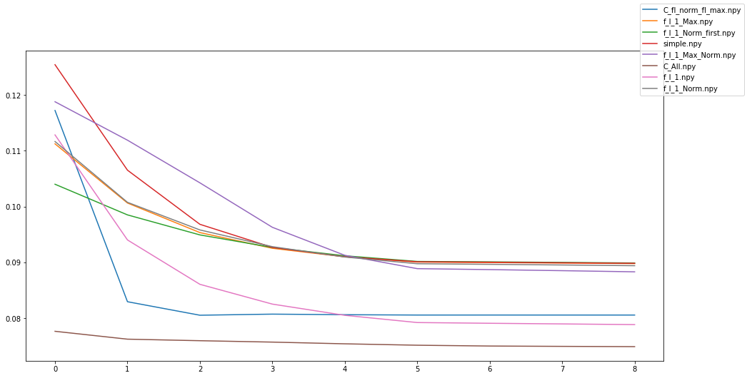

Hybrid Models

- Resnet18
- U-Net

Resnet18
Conv2D
21 x 31
Conv2D
11 x 16
Conv2D
23 x 23
Conv2D
21 x 21
ResNet
Output 1000 feature

Reshape to 2D array (40,25)
and up-sample

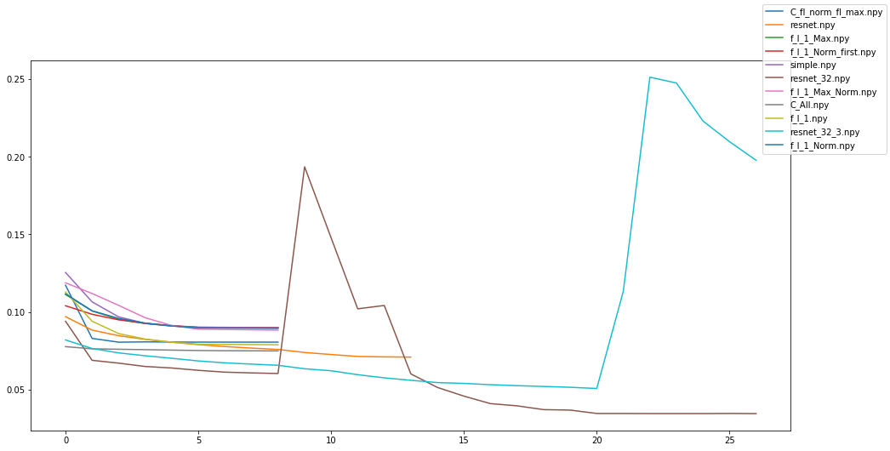
U-Net
U-Net by nature has an internal architecture that looks like an encoder so no extra layers were added
We experimented pre-trained U-net weights and from scratch training

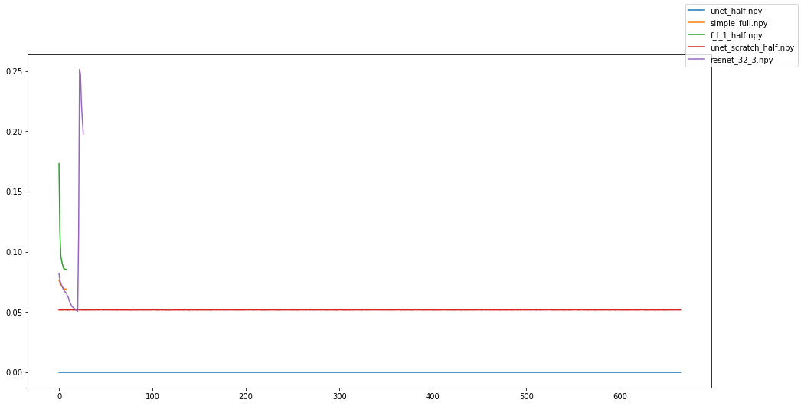

Model based on Hex representation:
Generally its impleneted by making the output of 2d layer to be 16 channel(number of hex) and apply softmax of the number of channel axis.

Since in hex representation number of elements is much less than binary most of the image will be padding so we compare between Center and right padding in the following image.
Model chives slightly better on Right padding
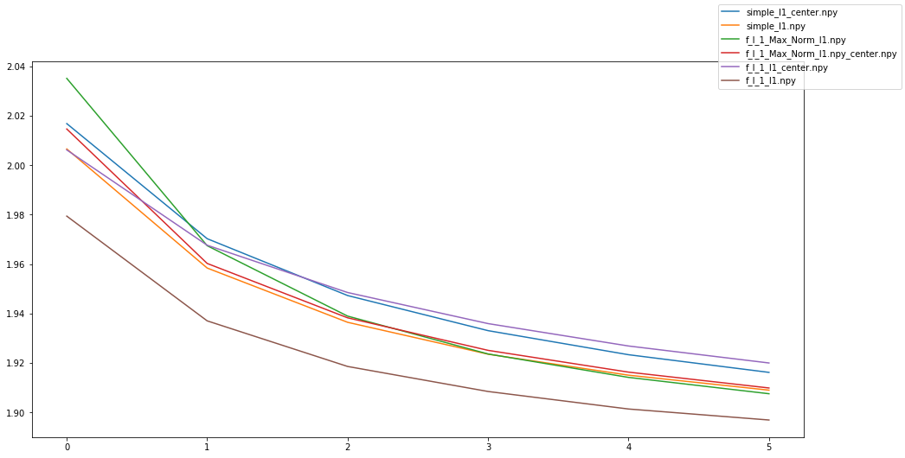

U-Net with hex representation
Input is right padded and up-sampled to reach dimension of 256x256 then convoluted to the dimension of 64x64 again after its output from pre-trained model.

Model has input channel of 3 and output of one
Conv2D
65x65
Conv2D
65x65
U-Net
Conv2D
65x65
Conv2D
65x65
we concatenate the around the channel dimension of input.

We get output of CONV2D after the U-net to be of 16 channels

Name | Train Loss | Val Loss | Activation  (Last layer) | Data type | Data size | Input dimension | Padding | #  Epoch | LR | Comments
Simple | 0.855 | 0.859 | Sigmoid | Bin | Small | 112x112 | Right | 6  3 | 1e-3  1e-4 | Still there is room for improvement  Wasn’t implemented correctly
Simple | 1.89902 | 1.89695 | Softmax | Hex | Small | 112x112 | Right | 6 | 1e-3
Simple | 1.91967 | 1.90 | Softmax | Hex | Small | 112x112 | Center | 6 | 1e-3
Four layer | 0.0746 | 0.07503 | Sigmoid | Bin | Small | 112x112 | Right | 6  3 | 1e-3  1e-4 | Started to over-fit
Four layer | 1.899024 | 1.89695 | Softmax | Hex | Small | 112x112 | Center | 6 | 1e-3
Four layer | 1.9233 | 1.920011 | Softmax | Hex | Small | 112x112 | Center | 6 | 1e-3
Normalize | 0.08799 | 0.08835 | Sigmoid | Bin | Small | 112x112 | Right | 6  3 | 1e-3  1e-4 | Could be trained for more epochs
fl_max_norm | 0.08693 | 0.08731 | Sigmoid | Bin | Small | 112x112 | Right | 6  3 | 1e-3  1e-4
fl_max_norm | 1.90763 | 1.90757 | Softmax | Hex | Small | 112x112 | Right | 6 | 1e-3
fl_max_norm | 1..91300 | 1.90990 | Softmax | Hex | Small | 112x112 | Center | 6 | 1e-3
fl_max | .088807 | .08920 | Sigmoid | Bin | Small | 112x112 | Right | 6  3 | 1e-3  1e-4 | Started to overfit
Combined | .077447 | .077867 | Sigmoid | Bin | Small | 112x112 | Right | 6  3 | 1e-2  1e-4 | Takes more time
Al in All | .070321 | .07069 | Sigmoid | Bin | Small | 112x112 | Right | 6  3 | 1e-2  1e-4 | Best result
f_l_1_Norm_first | .08886 | .0892174 | Sigmoid | Bin | Small | 112x112 | Right | 6  3 | 1e-3  1e-4 | Over-fit fastly
ResNet | .060458 | .060137 | Sigmoid | Bin | Small | 112x112 | Right | 9  9  2  6 | 1e-2  1e-2  1e-1/2  1e-2 | This phase trains only the last customized layers  Unfreeze the whole model  This will cause a jump in loss  The model again started to decrease a cuda  Actually resnet looks promising but didn’t take chance to be trained more carefully with more data
U-Net  Pre-trained | .000778 | 2.765e-5 | Sigmoid | Bin | Medium | 256x256 | Right | 1 | 1e-4 | Best Result  Takes Long time
U-Net  Pre-trained | 1.90944 | 1.90867 | Softmax | Hex | Small | 64x64 | Right | 1  2 | 1e-3/2  1e-4 | The loss barely enhance
U-Net  Scratch | 0.219918 | 0.05173 | Sigmoid | Bin | Medium | 256x256 | Right | 1 | 1e-4 | The loss was decreasing

Note:Last Layer activation implies the loss function used
U-net achives the best results
We need to use a meter to compare between Cross entropy and binary cross entropy.
For consistency models need to be trained on the same amount of data.
Resnet could have a try specially because it’s much faster than U-Net
U-Net achieves barely the same loss of much simpler architectures when dealing with hex data.

